UMM Library System - Technical Documentation

# 1. Introduction

The UMM Library System is a Java-based desktop application developed using JavaFX. It facilitates book borrowing, returning, member management, and administrative controls for managing a digital library within a campus environment.  
This document elaborates on the system architecture, class diagrams, functional flowcharts, major components, and instructions for both users and administrators.

# 2. System Architecture

The application is organized in a modular structure utilizing Java modules and packages. It is based on the MVC (Model-View-Controller) design pattern and uses plain text file storage for data persistence.  
  
- Models: Represent entities like Book, Member, and User.  
- Views: Implemented using JavaFX for GUI.  
- Controllers: Handle user interactions and business logic.  
- Storage: Manages data using text files.

Modules:

* - com.practicum.models  
  - com.practicum.users  
  - com.practicum.controllers  
  - com.practicum.storage  
  - com.practicum.gui

# 3. Class Diagram

The following is the class diagram that defines the main entities and their relationships:

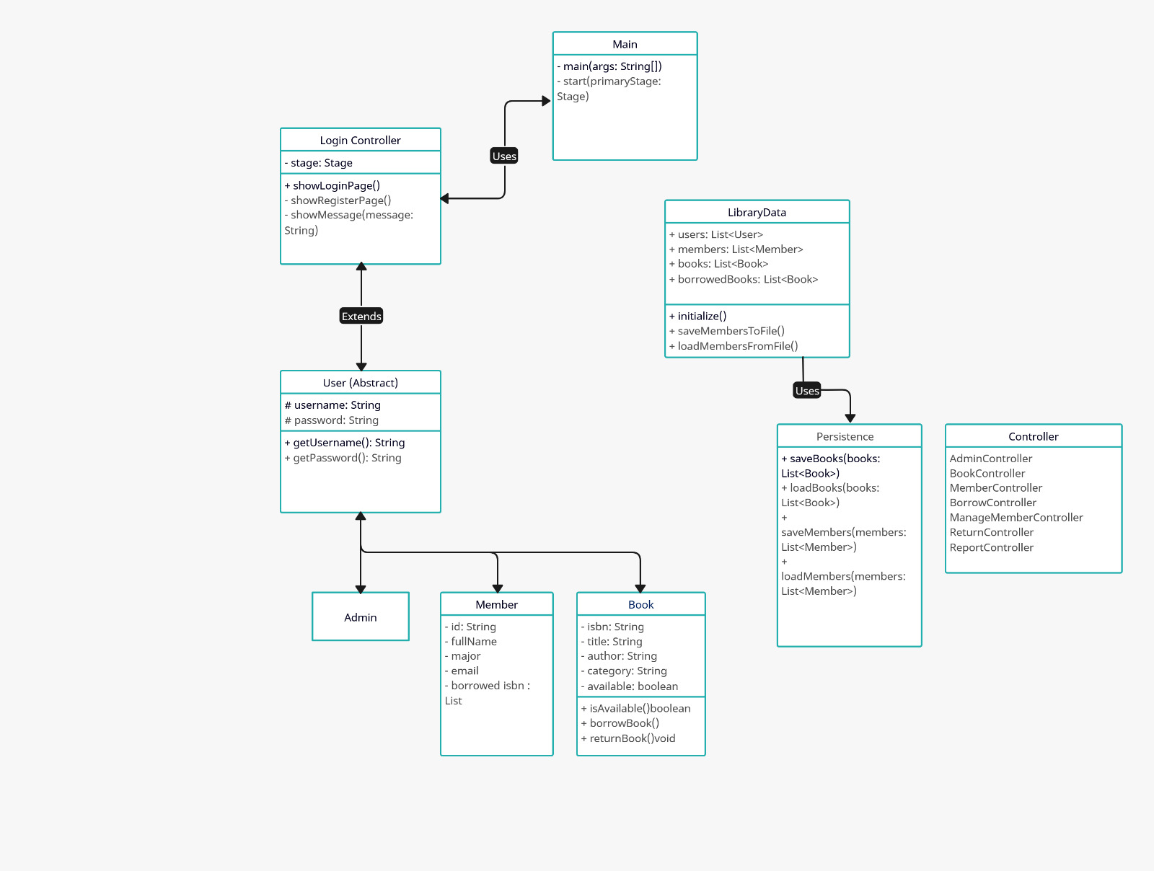

# 4. Workflow and Features

The application begins with a login interface. Based on the user's role, it directs them to either the admin dashboard or the member dashboard. Features include:

- Admin Features:  
 - Register new members  
 - View, add, or delete books  
 - View reports of borrowed and returned books  
  
- Member Features:  
 - Search books  
 - Borrow and return books  
 - View personal borrowed book history

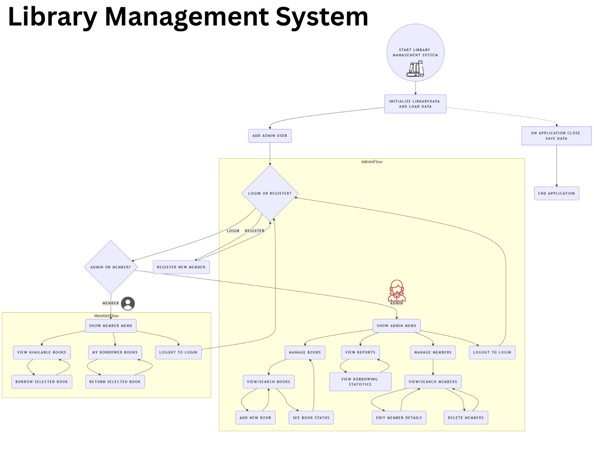Flow Description:

1. User logs in → System validates credentials  
2. If Admin → Show Admin Dashboard  
3. If Member → Show Member Dashboard  
4. Admin selects an option (e.g., Manage Books) → Displays relevant page  
5. Member borrows or returns book → System updates book availability and member data

# 5. Key Class Descriptions

- Book: Represents a library book (ISBN, Title, Author, Availability).

- Member: Represents a library member (ID, Name, Major, Borrowed Books).

- User: Superclass for Admin and Member.

- LibraryData: Static storage and methods for reading/writing data from/to text files.

- Session: Holds the current logged-in user.

# 6. User Instructions

To use the system:  
1. Run the application.  
2. Login using admin or member credentials.  
3. Navigate using the UI buttons.  
4. Admins can register members and manage the book database.  
5. Members can borrow or return books using the provided forms.

# 7. Conclusion

This system simplifies library operations for both staff and students. With a clean UI and well-structured backend, it provides a maintainable and user-friendly experience. It can be extended with a database backend or web-based frontend in future iterations.